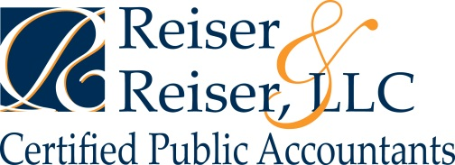

Small BUSINESS TAX CHECKLIST

Income
- Gross receipts from sales or services
- Sales records (for accrual based taxpayers)
- Inventory (if applicable)
  - Beginning inventory
  - Inventory purchases
  - Ending inventory
  - Items removed for personal purposes
- Returns and allowances
- Business checking/savings account interest (1099-INT or statement)
- Other income

Expenses
- Advertising
- Transportation and travel expenses
  - Local transportation
    - Business trip (mileage) log
    - Contemporaneous log or receipts for public transportation, parking, and tolls
  - Travel away from home
    - Airfare or mileage/actual expense if drove
    - Hotel
    - Meals, tips
    - Taxi, tips
    - Internet connection (hotel, Internet café etc.)
    - Other
- Commissions paid to subcontractors
  - File Form 1099-MISC and 1096 as necessary
- Depreciation
  - Cost and acquisition date of assets
  - Sales price and disposition date of any assets sold
- Fringe benefits
  - Employer-paid pension/profit sharing contributions
  - Employer paid HSA contributions
  - Employer-paid health insurance premiums
  - Cost of other fringe benefits
- Business insurance
  - Casualty loss insurance
  - Errors and omissions
  - Other
- Interest expense
  - Mortgage interest on building owned by business
  - Business loan interest
- Legal fees
- Office supplies
  - Pens, paper, staples, etc
  - Other consumables
- Rent expense
  - Office space rent
  - Business-use vehicle lease expense
  - Other
- Office-in-home
  - Square footage of office space (hours of use for daycare business, only square footage is required for the new standard office-in-home deduction)
  - Total square footage of home (not applicable for daycare business)
  - Mortgage interest or rent paid
  - Utilities
- Wages paid to employees
  - Form W-2 and W-3
  - Federal and state payroll returns (Form 940, etc.)
- Other expenses
  - Repairs, maintenance of office facility, etc
  - Other business related expenses

